10.9789/2175-5361.rpcfo.v16.13338
Artigo original
Raphael Gialluisi da Silva Sá Ferreira¹ 0000-0003-4943-3766
Erica Ripoll Hamer² 0000-0002-5574-458X
Alexandre Ribeiro Bello³ 0000-0003-1391-9967

¹Instituto Nacional de Câncer, Rio de Janeiro, Rio de Janeiro, Brasil.
²⁻³Universidade do Estado do Rio de Janeiro, Rio de Janeiro, Rio de Janeiro, Brasil.

AUTOR CORRESPONDENTE: Erica Ripoll Hamer
Email: erica@ripoll.com.br

Recebido em: 29/05/2024
Aceito em: 14/06/2024

Benchmarking dos erros pré-analíticos no laboratório de patologia clínica do hospital do cancêr I

Benchmarking of pre-analytical non-conformities in the clinical pathology laboratory at hospital do câncer I

Benchmarking de no conformidades preanalíticas en el laboratorio de patología clínica del hospital do câncer I

RESUMO
Objetivo: rastrear os principais erros do processo da fase pré-analítica do Laboratório de Patologia Clínica e realizar um benchmarking com o estudo internacional coordenado pela IFCC (Federação Internacional de Química Clínica). Método: foram acompanhados quatorze indicadores pertencentes à fase pré-analítica, utilizando os dados contidos no sistema LIS. Foram calculados os defeitos por milhão de oportunidades (DPMO) e SIGMA de cada indicador e realizado benchmarking com a IFCC. Resultados: foram rastreados 5.541 erros nos 14 indicadores, e 8 desses indicadores do Inca apresentaram pontuações maiores ou iguais quando comparados ao IFCC. Hemólise e fibrina após centrifugação foram os indicadores com pior índice e deveriam receber maior atenção pelas equipes laboratoriais. Conclusão: um Manual de Gerenciamento de Erros Pré-analíticos foi elaborado para padronizar processos, melhorar indicadores e manter a qualidade daqueles que são minimamente aceitáveis.
DESCRITORES: Erros laboratoriais; Erros pré-analíticos; Benchmarking; Garantia de qualidade do paciente.

ABSTRACT
Objective: to track the main errors in the process of the pre-analytical phase of the Clinical Pathology Laboratory and perform a benchmarking with the international study coordinated by the IFCC (International Federation of Clinical Chemistry). Method: fourteen indicators belonging to the pre-analytical phase were tracked, using the data contained in the LIS system. Defects per million opportunities (DPMO) and SIGMA of each indicator were calculated and benchmarking was performed with IFCC. Results: a total of 5,541 errors were tracked in the 14 indicators, and 8 of these Inca indicators displayed higher or equal scores when compared to IFCC. Hemolysis and fibrin after centrifugation were the indicators with the worst index and should be paid more attention by laboratory teams. Conclusion: the Pre-analytical Error Management Manual was prepared to standardize processes, improve indicators and, maintain the quality of those that are minimally acceptable.
DESCRIPTORS: Laboratory errors; Pre-analytical errors; Benchmarking; Patient quality assurance.

RESUMEN
Objetivo: rastrear los principales errores en la fase preanalítica del Laboratorio de Patología Clínica y compararlos con el estudio internacional coordinado por la IFCC (International Federation of Clinical Chemistry). Método: se realizó el seguimiento de catorce indicadores pertenecientes a la fase preanalítica a partir de los datos contenidos en el sistema LIS. Se calcularon los defectos por millón de oportunidades (DPMO) y el SIGMA de cada indicador y se compararon con los de la IFCC. Resultados: se rastrearon 5.541 errores en los 14 indicadores, y 8 de ellos obtuvieron puntuaciones superiores o iguales a las del IFCC. La hemólisis y la fibrina tras la centrifugación fueron los indicadores con peores puntuaciones y deberían recibir mayor atención por parte de los equipos de laboratorio. Conclusión: se elaboró un Manual de Gestión de Errores Preanalíticos para estandarizar los procesos, mejorar los indicadores y mantener la calidad de los mínimamente aceptables.
DESCRIPTORES: Errores de laboratorio; Errores preanalíticos; Benchmarking; Garantía de calidad del paciente.

INTRODUCTION
Quality management has been improved by clinical laboratories with the use of standardized procedures pursuing laboratory quality and ensuring that test results faithfully reflect the clinical condition presented by patients. The guarantee of reliable results, with minimal errors and interferences, favors the organization and control of the stages that comprise the pre-analytical, analytical, and post-analytical phases.
The initial phase of performing a test is the pre-analytical phase, which starts when the test is requested, goes through obtaining the sample, and ends when the analytical phase begins. The post-analytical phase includes the issuing and checking of results by the responsible technician.¹ Among these three stages, the pre-analytical phase is the most susceptible to errors, the processes involving the pre-analytical phase are difficult to control, as most can occur outside the laboratory environment. Failures in this phase represent 46% to 68.2% of errors in clinical analysis laboratories. Several factors can cause errors or variations in the result at this stage, such as incorrect identification of the patient and the sample, inadequate patient preparation, inadequate sample collection, unsuccessful forwarding, and transport of the collected biological material.²⁻³
Error tracking is an initial step in quality control of pre-analytical errors, so it is necessary to assess whether the quantity of errors found is acceptable to the laboratory's desired standards. The Sigma metric (6 Sigma) is a statistical resource widely used by organizations in different areas, recognized as one of the best metrics to indicate the magnitude of failures in processes. Evaluates the number of defects per million opportunities (DPMO). Six Sigma is a system for evaluating the performance of a process to decrease its variability to achieve perfection and meet customer requirements. The use of this tool serves to support process improvement and thus improve the level of product or service quality, as well as making it possible to compare performance between different processes and organizations, benchmarking. The comparative vision of the market proposed by benchmarking programs allows for consistent decision-making based on data.⁴⁻⁵
A 6 Sigma process produces no more than 3.4 defects per million opportunities, where "defect" is defined as any characteristic of the product or service outside the specifications perceived by the customer. This process is obtained by the difference in standard deviations between the mean and its upper limit.⁶
Inca, the National Cancer Institute, is the auxiliary body of the Ministry of Health in the development and coordination of integrated actions for the prevention and control of cancer in Brazil. The institute has five hospital units, with the Hospital do Cancer I as its central unit, with an outpatient service volume of 198,760 (one hundred and ninety-eight thousand seven hundred and sixty) consultations in the year 2018. In the year 2019, by consulting the Laboratory Information System (LIS), approximately 2,000,000 (two million) tests were performed in approximately 250,000 (two hundred and fifty thousand) consultations, adding outpatients and inpatients.⁷
The activities developed in clinical laboratories include processes and techniques to perform laboratory tests, which are responsible for 65% to 75% of the information that assists the physician in clinical diagnosis. Also seeking customer satisfaction, process standardization, and the improvement of laboratory analysis, the implementation of a quality management system becomes necessary.⁸
The objective of this study was to track the main errors in the process of the pre-analytical phase of the Clinical Pathology Laboratory and perform a benchmarking with the international study coordinated by the IFCC (International Federation of Clinical Chemistry).

METHODS
Screening for pre-analytical errors
Pre-analytical errors were evaluated using laboratory indicators, which are numerical measures of errors or failures of a given process relative to its total number (hits and misses). The performance of a process is considered satisfactory if it is within the limits set by the indicators. Their purpose is not to provide answers, but to indicate potential problems that need preventive actions.⁹⁻¹⁰
The indicators analyzed were adapted from the table of pre-analytical indicators recommended by the IFCC-WG-LEPS (Working Group on Laboratory Errors and Patient Safety of the International Federation of Clinical Chemistry and Laboratory Medicine).³
The following indicators were selected: incorrect storage, errors arising from the collection (blood collection error), registration and reception errors, and transport errors.
For "blood collection error" the following indicators were selected: inadequate sample, inadequate vial, coagulated sample, hemolysis, sample/anticoagulant volume ratio, and insufficient volume.
For "registration and reception errors", the following were selected: patient identification errors and incorrect test registration.
Other possible screening errors selected for the study were: tube loss, and the presence of fibrin after the centrifugation process.
The parameter "hemolyzed sample" was measured by evaluating the serum index, a test performed in all samples that are analyzed by the Serumimmune and Coagulation sectors. In the Immunosorbent sector, the test was performed in the Roche Cobas C501 equipment, using the kit called SI2, and in the Coagulation sector, the ACL Top 500 equipment from the manufacturer IL - Instrumentation Laboratory, and the evaluation was performed by optical analysis.
Data collection took place over 360 days of the year 2019, (in the period from 01/01/2019 to 31/12/2019), using queries created in our database (LIS) of the Diagnosis system and Interface Software (Connect), both manufactured by the company Matrix.

Treatment of the collected data
The Sigma metric¹¹ was obtained from the level of process failures by a specific calculation and the formula calculation tool of the Microsoft Excel program was used by entering the calculation command line: formula INV.NORMP (1 - (result/1000000)) + 1.5. The values above 6 were rounded to 6 since this is the maximum value intended by the 6 Sigma system.
This study was benchmarked against the study conducted by the IFCC.

RESULTS
The data was collected from 01/01/2019 to 12/31/2019 after the LIS consultation mechanism was set up. The collected data was exported to a file in .xlsx format (Excel program extension) for clustering and analysis.
In 2019, the Immunochemistry Sector processed 129,643 (one hundred and twenty-nine thousand, six hundred and forty-three) samples, and the Hematology Sector processed 98,482 (ninety-eight thousand, four hundred and eighty-two) samples, for a total of 228,125 (two hundred and twenty-eight thousand, one hundred and twenty-five) samples processed.
The initial analysis of the data certified the occurrence of 5,474 (five thousand four hundred and seventy-four) pre-analytical errors in the research period, which caused the cancellation of tests, delays in the release of results, and recollection. This quantity represents an error present in 2.4% of all samples processed by the sectors studied.
In Table 1, the twelve (12) errors reported, and their respective codes are listed.

Table 1 - Number of occurrences of pre-analytical errors, their respective codes according to IFCC, DPMO, and Sigma value
Types of errors Reported | Code | Quantitative | SIGMA
Incorrect Storage | IN057 | 15 | 5,7
Transport error | IN059 | 2 | 6,1
Collection error: unsuitable sample | IN062 | 143 | 5,1
Collection error: unsuitable flask | IN063 | 82 | 5,3
Collection error: Coagulated sample | IN064 | 59 | 5,4
Collection error: Hemolysis | IN069 | 3983 | 4,2
Patient ID error | IN073 | 18 | 5,6
Incorrect test registration | IN074 | 14 | 5,7
Collection error: sample / anticoagulant volume ratio error | IN086 | 28 | 5,5
Collection error: insufficient volume | IN087 | 37 | 5,5
Lost tubes * | - | 29 | 5,5
Fibrin after centrifugation * | - | 985 | 4,6
Total |  | 5,474

Source: The Author, 2022. * Errors not listed in the IFCC study;

The Sigmas values calculated in the three studies are shown in Table 2, the IFCC study does not include data on the recollection indicator, and it is possible to benchmark with 10 indicators.
Table 2 - INCA Benchmarking and the IFCC study.
Indicators | INCA | IFCC
Incorrect storage | 5,7 | 6,0
Transport error | 6,0 | 6,0
Unsuitable Sample | 5,1 | 5,5
Improper bottle | 5,3 | 5,2
Clotted samples | 5,4 | 4,3
Hemolysis | 4,2 | 3,6
Error in patient Identification | 5,6 | 5,0
Incorrect test registration | 5,7 | 4,5
Error in sample volume / anticoagulant ratio | 5,5 | 4,2
Insufficient volume | 5,5 | 4,9
Source: The Author, 2022.

In graph 1, it is possible to graphically visualize the percentage impact of the hemolysis indicator and the other indicators added together.

Graph 1 - Graphic representation comparing the representativeness of the hemolysis indicator to the other indicators
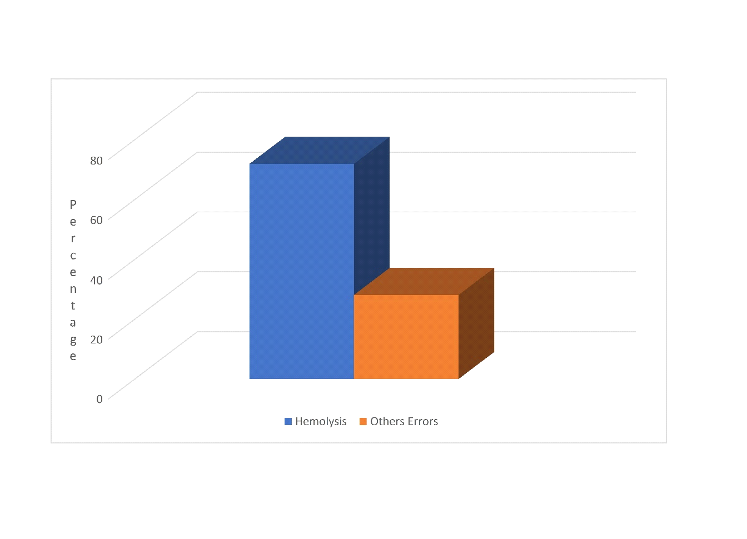Source: The author, 2022.

The blood collection error, were representative of the total errors due to the high incidence of hemolysis in the collected samples (Graph 2).

Graph 2 - Graphical representation of blood collection errors
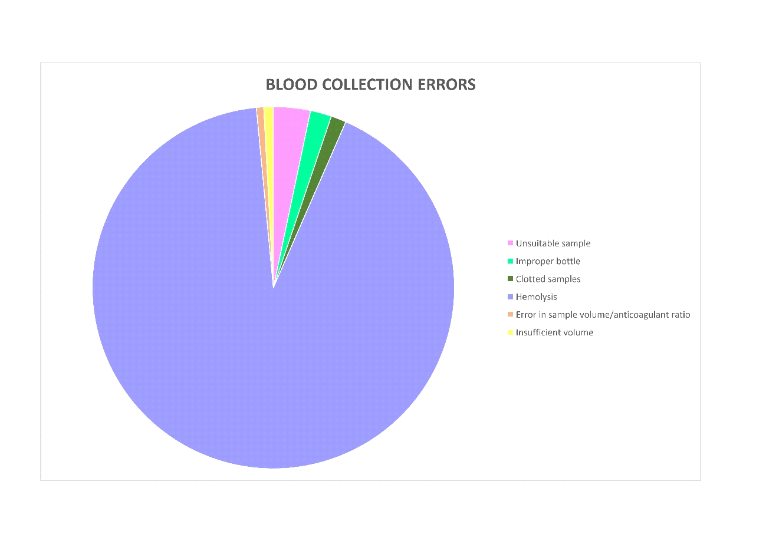

Source: The author, 2022.

The radar chart (Graph 3), shows the comparison between the IFCC study and the Sigma metric

Graph 3 - Comparative graph of the INCA X IFCC errors studies, using the Sigma metric
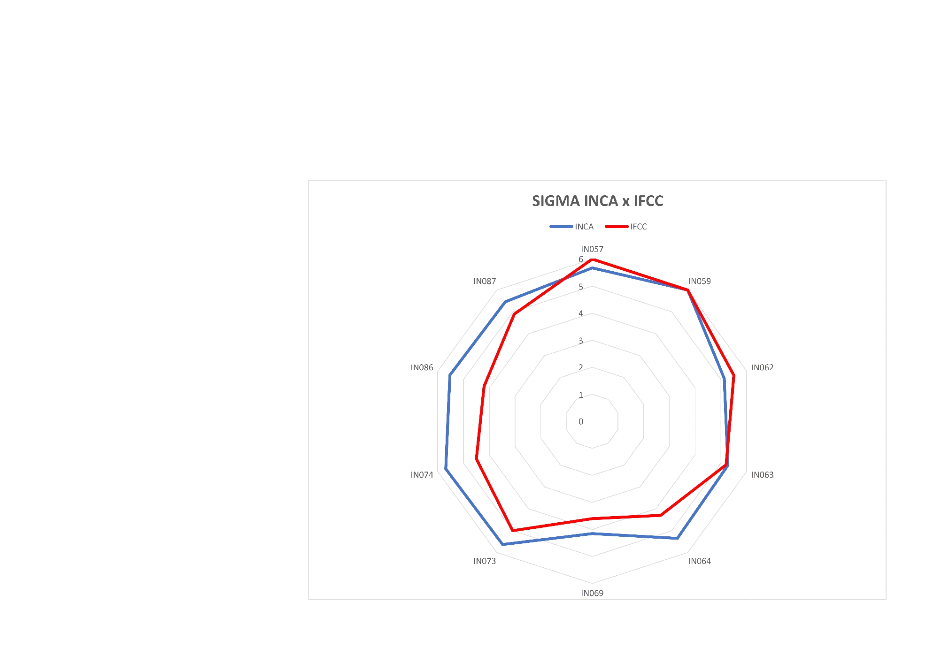
Source: The author, 2022.

DISCUSSION
Overview of the errors
When considering only the absolute numbers of errors, it was evident that collection is the procedure in the pre-analytical phase that had the most impact on the errors tracked in 2019, accounting for almost 75% of the total errors, and two indicators, hemolysis and fibrin formation (after the centrifugation process) were the most representative when added together they represent about 90% of the total errors. The other errors added together, approximately 10% of the total errors, present the blood collection error (inadequate sample), the most prevalent, with approximately 3% of occurrences. Although the 12 errors do not have a prevalence of 10% of the total, it does not exclude the need for actions to reduce their incidence.
Among all the indicators tracked by this study, the indicators of transport error and tube breakage in the centrifugation process are at the perfection level of the Sigma metric, both Sigma level 6.
The percentage of total errors (2.4%) is a high value of the data prospected in the review work of Sousa et al., (2021), who reported that about ten reviewed papers had an error lower than 0.5%, while two studies had higher percentages, 2.7%, and 7.5%.¹²
Although the HCI Laboratory has a high incidence, most samples with errors present were able to be used after analysis by the sample rejection criteria.

Tracked Errors and Benchmarking
Hemolysis accounted for many reported errors (3,983 errors).
Graph 1 perfectly illustrates this impact on total errors. This scenario was similar to what was described by Sciacovelli et al. (2019). Noting that hemolysis is the most reported error in the literature, although it cites that it depends on a subjective evaluation since many laboratories make this evaluation by visual means.
Inca uses the automated serum index evaluation methodology, standardizing the evaluations, making the detection of hemolysis more sensitive, and maybe a probable cause of this high rate of occurrence.
Another advantage of this method is the possibility to process samples and refuse only tests in which the presence of hemolysis is likely to interfere with the result.¹³
This possibility of releasing all or part of the results of a hemolyzed sample makes the impact of this error smaller when compared to laboratories that reject the hemolyzed sample using only visual assessment to qualify the sample. However, this procedure is controversial because there is no standardization among manufacturers for calculating the concentration of free hemoglobin in hemolyzed blood.
Simundic et al. addresses this issue in a survey conducted among 1,405 (one thousand four hundred and five) institutions in 37 European countries and revealed that 53.8% of the laboratories use the hemolysis cohorts informed by equipment manufacturers, while 37.4% use visual verification, after defining that there is hemolysis in this sample only 20% discard the sample and the rest discard only the tests that suffer interference due to the level and hemolysis found.¹³
INCA is an institute that cares for oncologic patients, therefore, the collection procedure is difficult, since they are patients with peripheral venous access compromised by the treatment to which they are submitted, leading to an increase in the incidence of hemolysis.
Other causes can be the use of small-caliber needles or scalpels, tourniquet time, antiseptic drying time, vigorous transfer of blood into the tube when performed with a syringe, (pulling the embolus too hard at the time of collection), collecting volume smaller than the tube mark indicates, and vigorous shaking of the tube with the collected sample.¹⁴
The Inca Sigma value for hemolysis was 4.2, while by the IFCC an average Sigma value of 3.59 was found in the year 2018, considering laboratories that perform automatic identification of hemolysis.
The second most recurrent error was the presence of fibrin after the centrifugation process, an error that delays sample processing and delivery of the result, however, the sample is still viable for analysis. This error represents 0.43% of the total samples and approximately 19% of the total errors. The Sigma value of 4.6 for this indicator is well below the standard of perfection desired for any indicator.
Lee, in his study conducted at Korea University Hospital, reported an occurrence of fibrin in 36.47% of pre-analytical errors, approximately double the percentage found in the laboratory survey. The IFCC does not track this indicator.¹⁵
The main causes for this occurrence were: (i) collections in heparinized catheters without the correct preparation of discarding six times the volume before collection, (ii) collection with the wrong volume, (iii) changing the correct proportion with the additive (depending on the type of additive) not complying with the marking indicated by the tube manufacturer, (iv) not respecting the minimum time for clot retraction indicated by the tube manufacturer, and (v) centrifugation with less than the recommended time.¹⁶
The number of "incorrectly stored samples" at Inca was low, but it should be considered that most of the tests are performed on the same day of collection, so there is no need to store the sample for the analysis. The occurrence of this error was slightly higher (Sigma 5.7) compared to the results obtained in the study by Sciacovelli et al.
Their study recorded data in 2018, from 118 labs, and it was reported that 25% of labs achieved a Sigma value of 5.46 or less, another 25% with Sigma between 5.46and 6.0. However, 50% of the remaining labs found themselves at the Sigma value of perfection, Sigma value 6.¹¹
The inadequate samples, in most cases, were collected from catheters, or from the region where there was some functional venous access. Tracking this error is very difficult, requiring checking results that are incompatible with the patient's history or unlikely results, which leads to the possibility of doubt about the quality of the material.
Other cases have been reported such as liquids with high viscosity, which makes pipetting by the equipment impossible, 24-hour urine, which was sent as only an isolated sample. In this indicator Inca (Sigma value 5.1) was slightly below the value found when compared to the IFCC study (Sigma 5.5).
The clotted samples are most common in the hematology department, and the main origin of this error is in the inversion of the tube for the dissolution of the anticoagulant present in the tube.
Another factor causing clotting of the sample is the difficulty of blood collection for cancer patients, which leads to delays in obtaining the volume needed for testing. The IFCC value (4.3) was considerably lower than the INCA value (5.4).
The patient identification errors occurs mostly in the identification of collection vials in inpatients, incorrect information of the name and bed of the patient in the tube (primary identification), or the exchange of barcode labels. In this indicator, the calculated Sigma of INCA (5.6) was higher than the IFCC (5.0).
Incorrect registration of tests occurs when manual orders are made, due to some failure in the electronic test ordering system, incorrect registration of test additions in samples already collected, or in outpatient care.
INCA, probably by using electronic ordering, manages to have control of this error, when compared to the other studies. INCA's Sigma value (5.7) is much higher than that reported by the IFCC (4.5).
The errors in sample volume/anticoagulant ratio occurs mainly in samples from the hematology/coagulation sector and is due to collection difficulty, lack of vacuum in the collection tube, or lack of technical knowledge of the professional who performed the procedure, which is very common when the sample is collected by professionals who do not belong to the laboratory team. Again, INCA has a Sigma value (5.5) higher than the IFCC (4.2).
The volume error, collecting insufficient volume to perform the exam is usually caused by the difficulty in collecting the material to be analyzed and also by the unpreparedness of the professional involved in the collection. In some rare cases, there is the reverse problem, a collection of the material above the volume that is recommended by the manufacturer of the withdrawal tubes. This problem occurs from open systems collection and the transfer of the collected material into the collection tube without respecting the existing limit mark on the respective tube. This indicator has similar behavior to the studies, INCA (5.5) and IFCC (4.9).
Misplacement of tubes is an error that is difficult to track; most of the samples in the HCI laboratory are screened by the automated system. The loss can occur between the collection stage and the loading of the sample in the equipment or in the forgetfulness of sending the sample from the laboratory units of HC2 and HC3. The IFCC in its study makes a subdivision of the transportation error, and in this subdivision, there is the item misplaced sample. The average value of Sigma found in the year 2018 was 4.39, while the INCA was 5.5.

CONCLUSION
After the benchmarking, most of the indicators are in very close conditions, with almost all the results from Inca's laboratory having better values. An approach to improve these indicators became necessary. A review of the process was carried out, with the final product being the development of a Pre-analytical Error Management Manual.
The printed version of the manual will be distributed to the laboratory sectors and will also be available in digital format in the digital storage system of Inca's computer network, accessible to all laboratory employees and other hospital professionals.
The expectation with the implementation of this manual is the reduction of the incidence of errors, mainly regarding the formation of hemolysis and fibrin, and the maintenance of the indexes of the indicators that are at high-quality levels. It should also expand the indicators to be tracked by covering all sectors of the laboratory, especially the microbiology sector.
It is a great challenge to be able to implement this manual, despite the affinity of the laboratory professionals with the protocols defined in it. In general, teams that have been working for years, with long-established habits, have difficulty accepting and absorbing new procedures.
Even more challenging will be the implementation of these protocols in teams of professionals that are not part of the laboratory staff. This difficulty will be because these professionals are not used to the routine of a laboratory, due to a large number of professionals and their turnover.
Only by continuing to monitor indicators and maintaining rigor in the execution of protocols, will it be possible to control errors and ensure patient safety when it comes to laboratory tests and pre-analytical errors.

REFERENCES
1. Teixeira JCC, Chicote SRM, Daneze ER. Non-Conformities Identified During the Phases Pre-Analytics, Analytical, and Post-Analytical of a Clinical Analysis Public Laboratory. Nucleus. [Internet]. 2016 [cited 2024 jan 05];13(1). Available from: http://dx.doi.org/10.3738/1982.2278.1503.
2. Malacarne K. Modelo de gestão para laboratórios de análises clínicas: uma aplicação do Lean. [Mestrado em Engenharia de Produção e Sistemas]. Paraná (Brasil): Universidade Tecnológica Federal do Paraná; 2018. [acesso em 05 de janeiro]. Disponível em: http://repositorio.utfpr.edu.br:8080/jspui/handle/1/3166.
3. West J, Atherton J, Costelloe SJ, Pourmahram G, Stretton A, Cornes M. Preanalytical errors in medical laboratories: a review of the available methodologies of data collection and analysis. Ann. clin. biochem. [Internet]. 2017 [cited 2024 jan 05];54(1). Available from: https://doi.org/10.1177/0004563216669384.
4. Shcolnik W, Berlitz F, Galoro CA de O, Biasoli V, Lopes R, Jerônimo D, et al. Brazilian laboratory indicators benchmarking program: three-year experience on pre-analytical quality indicators. Diagnosis (Berl., Internet). [Internet]. 2020 [cited 2024 jan 05];8(2). Available from: https://doi.org/10.1515/dx-2020-0043.
5. Sciacovelli L, Lippi G, Sumarac Z, del Pino Castro IG, Ivanov A, De Guire V, et al. Pre-analytical quality indicators in laboratory medicine: Performance of laboratories participating in the IFCC working group “Laboratory Errors and Patient Safety” project. Clin. chim. acta. [Internet]. 2019 [cited 2024 jan 05];497. Available from: https://doi.org/10.1016/j.cca.2019.07.007.
6. De Almeida Berlitz F, Haussen ML. Seis sigma no laboratório clínico: impacto na gestão de performance analítica dos processos técnicos Six sigma in clinical laboratory: impact in analytical performance management of technical process.
7. Ministério da Saúde (BR). INCA - Instituto Nacional de Câncer [Internet]. 2018 [acesso em 16 de janeiro 2021]. Disponível em: https://www.inca.gov.br/.
8. Barbosa LO, Mansour SN. Project of quality management implementation based on the PALC standard and ONA methodology in a clinical analysis laboratory. RBAC. (Online), 2448-3877. [Internet]. 2018 [cited 2024 jan 05];50(4). Available from: https://doi.org/10.21877/2448-3877.201800701
9. Vieira KF, Shitara ES, Mendes ME, Sumita NM. A utilidade dos indicadores da qualidade no gerenciamento de laboratórios clínicos. J. Bras. Patol. Med. Lab. (Online). [Internet]. 2011 [acesso em 07 de maio 2024];47(3). Disponível em: https://doi.org/10.1590/S1676-24442011000300002.
10. Ricós C, García-Victoria M, de la Fuente B. Quality indicators and specifications for the extra-analytical phases in clinical laboratory management. Clin. chem. lab. med. [Internet]. 2004 [cited 2024 jan 05];42(6). Available from: https://doi.org/10.1515/cclm.2004.100.
11. Six Sigma Daily [homepage na internet]. Bisk. Six Sigma Tools: DPU, DPMO, PPM and RTY [cited 2022 feb 12]. Available from: https://www.sixsigmadaily.com/dpu-dpmo-ppm-and-rty/.
12. Sousa RL, Sousa DS, Barbosa MC de melo, Da Silva AF, De Resende LJ, Brito GC, et al. Erros pré-analiticos em laboratórios de análises clínicas: uma revisão / Pre-analytical errors in clinical analysis laboratories: a review. Brazilian j. heal. rev. [Internet]. 2021 [acesso em 05 de janeiro 2024];4(2). Disponívelm em: https://doi.org/10.34119/bjhrv4n2-416.
13. Simundic AM, Baird G, Cadamuro J, Costelloe SJ, Lippi G. Managing hemolyzed samples in clinical laboratories. CRC crit. rev. clin. lab. sci. [Internet]. 2020 [cited 2024 jan 05];57(1). Available from: https://doi.org/10.1080/10408363.2019.1664391.
14. Greiner Bio-One [homepage na internet]. Guia prático de Coleta de Sangue. Greineir Bio-One [acesso em 07 de janeiro 2024]. Disponível em: https://www.gbo.com/fileadmin/user_upload/Downloads/Brochures/Brochures_Preanalytics/Portuguese/GBO_Guia_Pratico_de_Coleta__2019_.pdf.
15. Lee NY. Reduction of pre-analytical errors in the clinical laboratory at the University Hospital of Korea through quality improvement activities. Clin. biochem. [Internet]. 2019 [cited 2024 jan 05];70. Available from: https://doi.org/10.1016/j.clinbiochem.2019.05.016.
16. Andriolo A, Martins AR, Ballarati CAF, Barbosa IV, Mendes ME, Melo MR de, et al. Recomendações da Sociedade Brasileira de Patologia Clínica Medicina Laboratorial para coleta de sangue venoso [livro na Internet], 2ª ed. São Paulo: Manole; [acesso em 07 mai 2024]. Disponível em: extension://efaidnbmnnnibpcajpcglclefindmkaj/https://controllab.com/wp-content/uploads/guia_coleta_sangue.pdf

